**Multithreaded Person Re-Identification System**

**CPM & Costing**

**Fund. Of Software Project Management**

**Members:**

**Salman Ahmed Khan (19K-1043)**

**Sadeem Sattar (19K-1102)**

**Abdullah Tilal Khan (19K-1103)**

**Gantt Chart:**

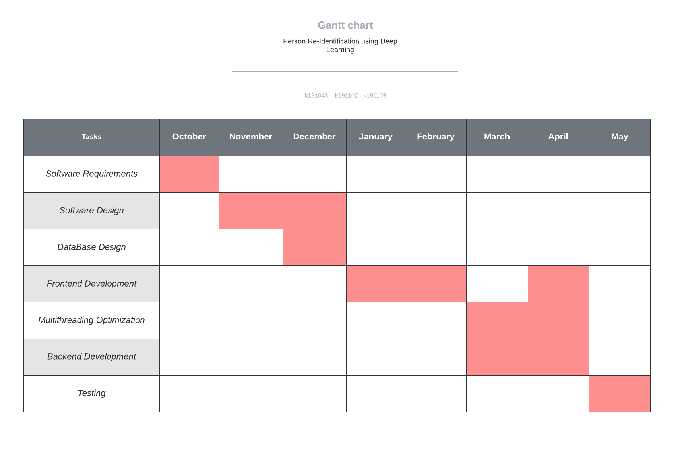

**CPM:**

|  |  |  |
| --- | --- | --- |
| Activities | Predecessor | Duration (Month) |
| Software Requirement Specification (SRS) | - | 1 |
| Software Design Specification (SDS) | SRS | 2 |
| Database Design (DD) | SDS (SS1) | 1 |
| Frontend Development (FD) | SDS, DD | 4 |
| Multithreading Optimization (MO) | FD (SS2) | 2 |
| Backend Development (BD) | FD (SS2) | 2 |
| Testing | FD, MO, BD | 1 |

**Graph:**

Software Requirement Specification = SRS, Software Design Specification = SDS, Database Design = DD, Frontend Development = FD, Multithreading Optimization = MO, Backend Development = BD, Testing = TS

0

|  |  |  |
| --- | --- | --- |
| 2 | DD | 3 |
| 2 | 1 | 3 |

|  |  |  |
| --- | --- | --- |
| 1 | SDS | 3 |
| 1 | 2 | 3 |

0

0

0

0

0

|  |  |  |
| --- | --- | --- |
| 0 | SRS | 1 |
| 0 | 1 | 1 |

|  |  |  |
| --- | --- | --- |
| 3 | FD | 7 |
| 3 | 4 | 7 |

0

0

|  |  |  |
| --- | --- | --- |
| 5 | MO | 7 |
| 5 | 2 | 7 |

0

0

|  |  |  |
| --- | --- | --- |
| 5 | BD | 7 |
| 5 | 2 | 7 |

|  |  |  |
| --- | --- | --- |
| 7 | TS | 8 |
| 7 | 1 | 8 |

0

0

0

**Costing:**

Salman Ahmed Khan – per hour = Rs. 7000

Sadeem Sattar – per hour = Rs. 3000

Abdullah Tilal Khan – per hour = Rs. 4500

Working = 20 hours per week

Developer’s Cost = developer hours * Working * Weeks (4) * Total Work Duration of Project (8)

Salman Cost = 7000 * 20 * 4 * 8 = Rs. 4,480,000

Sadeem Cost = 3000 * 20 * 4 * 8 = Rs. 1,920,000

Abdullah Cost = 4500 * 20 * 4 * 8 = Rs. 2,880,000

Total Cost = Rs. 9,280,000